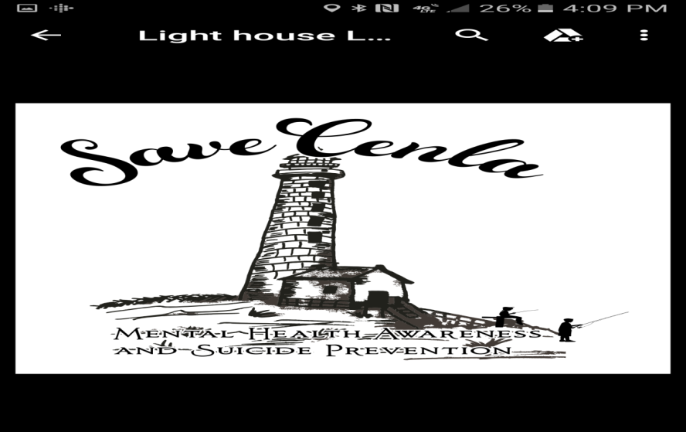

SaveCenla

P.O. Box 381

Dupont, LA 71329

Email: SaveCenla@yahoo.com

Website: SaveCenla.com

337-519-1888/337-288-0973 Tax ID #81-4863849

**SaveCenla invites you to participate in an**



**A**PPLIED **S**UICIDE **I**NTERVENTION **S**KILLS **T**RAINING

(Go to [www.SaveCenla.com](http://www.SaveCenla.com) for more information)

**Parent Permission Slip for ASIST Workshop**

Dear Parents,

Your student has been invited to attend a 2-day Applied Suicide Intervention Skills Training (ASIST) workshop on __________________, at ______________________________________. This training is evidence-based, created by LivingWorks Education (livingworks.net), and teaches participants the skills required to recognize a person who may be at risk for suicide, and work with them to create a plan that will provide immediate safety. This is a verbal, not physical intervention, and your student will not be required to provide long-term care. The goal is to save a person's life from acting on their thoughts of suicide, just as CPR is used to save a person's life from drowning. This life-skill will carry the students through high school, college, the work force, and family life for the rest of their lives. Upon completion of the workshop, students will receive a certificate from Livingworks stating that they are ASIST-certified. Please fill out the permission slip below, and bring it to your school's office as soon as possible. Lunch and snacks will be provided on both days. The training will be held within school hours and transportation will be provided by the school to and from the training location (if needed).

Best Regards,

SaveCenla

**---------------------------------------------------------------------------------------------------------------------------**

Date: ____________________

My child, ___________________________________________, has my permission to attend the 2-day

ASIST workshop held on ___________________. I understand that this is a 2-day workshop and my child will be required to arrive on time each day and attend the full 2-days in order to become certified - there will be no partial credit given. I also grant SaveCenla full permission for the free use of my child's picture in any broadcast, telecast, print account or any account in any medium used in connection with this event or future events of SaveCenla.

_______________________________________ _________________________________

guardian signature contact number